*Structure Of united states banking system*

*Parth Babbar*

*9999940289*

*Kishibabbar@gmail.com*

**Introduction:**

**Purpose And Scope:**

This document aims to provide an in-depth analysis of the US banking system. It covers the historical development, regulatory framework, types of banks, banking operations, risk management practices, technological advancements, current challenges, and future trends. The report plans to offer bits of knowledge into the complex functions of the financial area in the US and its imperative job in the economy.

**Overview of the US Banking System:**

The US banking system is an essential part of the nation's financial infrastructure, supporting stability and economic expansion. It is made up of a wide range of financial institutions that are subject to different state and federal regulations. The system guarantees the effective distribution of resources, offers a secure site for savings, gives credit to people and companies, and facilitates the operation of payment systems.

**Historical Background:**

The US banking framework has developed essentially since its origin. Important historical junctures include:

1. **1791:** The First Bank of the United States was established with the intention of managing the financial requirements of the new government and stabilizing and improving the nation's credit.  
   
2. **1816:** Creation of the 2nd Bank of the United States to address the economic chaos following the War of 1812.  
   
3. **1863:** The National Banking Act was presented with the goals of establishing a national banking system, a unified national currency, and easier government bond sales.  
   
4. **1913:** In order to provide the nation with a more secure, adaptable, and stable financial and monetary system, the Federal Reserve System was established in order to handle banking panics and establish a central monetary authority.  
   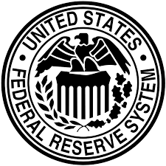  
   Seal used by Bank Governers.
5. **1933:** Establishment of the Glass-Steagall Act, isolating business and venture banking exercises to diminish the gamble of monetary hypothesis.  
   
6. **1999:** Gramm-Leach-Bliley Act repeal of the Glass-Steagall Act, allowing banks to combine commercial and investment banking services and provide a wider range of services.  
   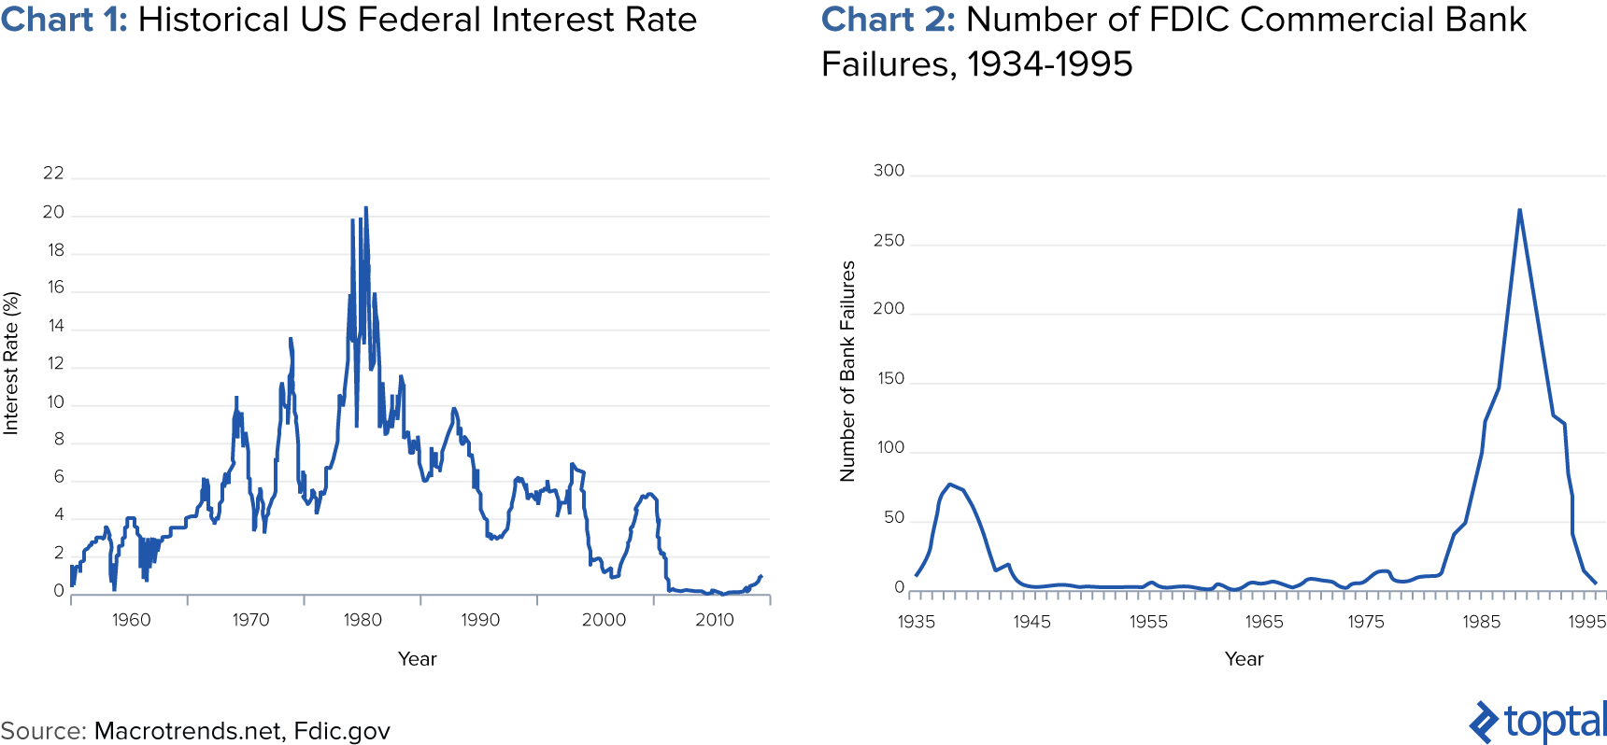
7. **2010:** Presentation of the Dodd-Straight to the point Money Road Change and Customer Security Act in light of the 2008 monetary emergency, expecting to lessen gambles in the monetary framework.  
   

**Regulatory Framework:**

The US banking framework is represented by a complex administrative structure including numerous offices:

1. **Federal Reserve System:** The national bank of the US, answerable for money related approach, oversight and guideline of banks, keeping up with monetary steadiness, and offering monetary types of assistance.
2. **Federal Deposit Insurance Corporation:** Insures bank and thrift deposits, encourages sound banking practices, and oversees receiverships. It was established in 1933 as a reaction to the Great Depression's bank failures.
3. **Office of the Comptroller of the Currency:** Regulates and oversees national banks and federal savings associations, assuring their safety and soundness.
4. **State Regulators:** Oversee banks and other financial institutions with state charters; each state has its own regulatory agency in place to guarantee the stability and safety of these establishments.

**Types of Banks:**

The US banking system comprises various types of banks, each serving different functions:

1. **Commercial Banks:** Offer a variety of services, such as taking deposits, granting loans, and providing investment goods. JPMorgan Chase, Bank of America, and Wells Fargo are a few examples.  
   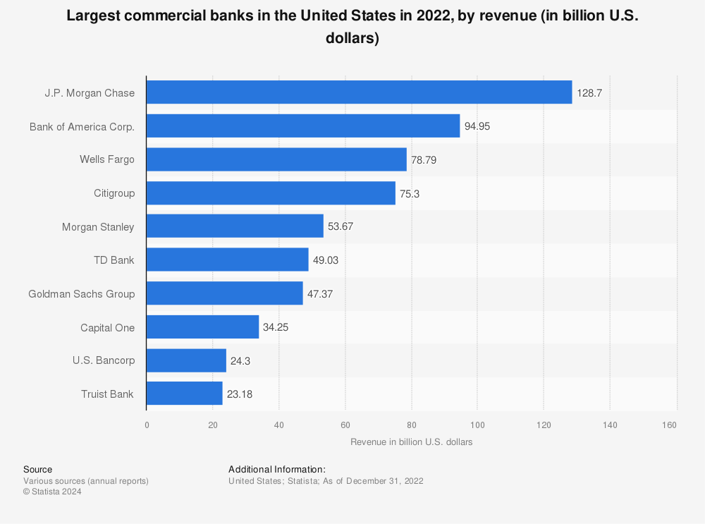
2. **Investment Banks:** Focus on offering advice services, enabling mergers and acquisitions, and underwriting. Morgan Stanley and Goldman Sachs are two notable companies.  
   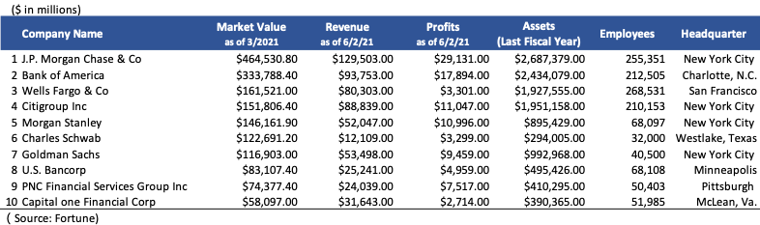
3. **Credit Unions:** Member-owned financial cooperatives that provide similar services to commercial banks while focusing on servicing their members. Examples include Navy Federal Credit Union and State Employees' Credit Union.  
   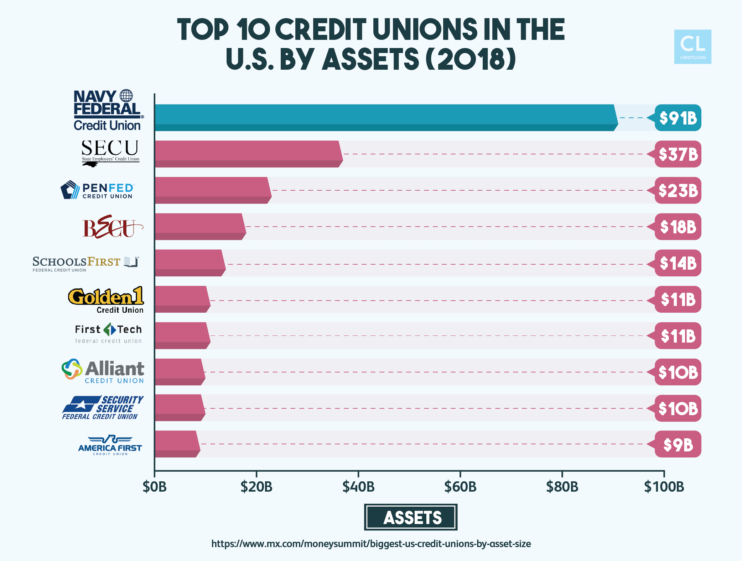
4. **Saving and Loan Associations:** Concentrate on receiving savings deposits and providing home loans. Examples are Citizens Savings and Loan and Third Federal Savings and Loan.  
   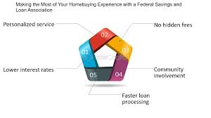
5. **Community Banks:** Smaller banks that focus on local communities and offer personalised banking services. Examples include Bank of the Ozarks and First Midwest Bank.

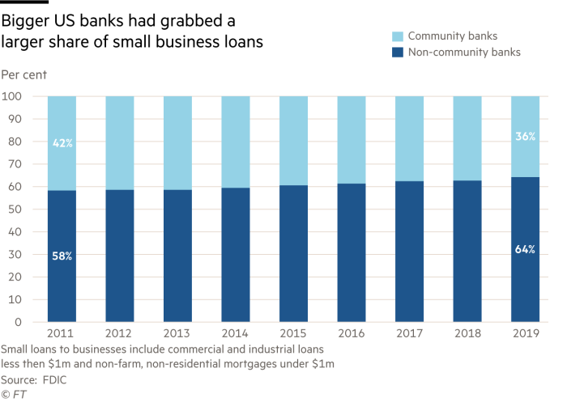

**Comparison with Banking Systems in Other Countries**

|  |  |  |  |  |  |
| --- | --- | --- | --- | --- | --- |
| **Aspect** | **United States** | **United Kingdom** | **Japan** | **China** | **India** |
| **Regulatory Framework** | Federal Reserve, FDIC, OCC, CFPB | Bank of England, FCA, PRA | Bank of Japan, FSA | People's Bank of China, CBIRC | Reserve Bank of India (RBI), SEBI, IRDAI |
| **Central Bank** | Federal Reserve | Bank of England | Bank of Japan | People's Bank of China | Reserve Bank of India |
| **Deposit Insurance** | FDIC (up to $250,000 per depositor) | FSCS (up to £85,000 per depositor) | Deposit Insurance Corporation of Japan | Deposit Insurance Fund (up to ¥500,000) | Deposit Insurance and Credit Guarantee Corporation (up to ₹5,00,000) |
| **Main Types of Banks** | Commercial, Investment, Credit Unions | Commercial, Investment, Building Societies | City Banks, Regional Banks, Shinkin Banks | Commercial, Policy Banks, Rural Banks | Public Sector, Private Sector, Cooperative Banks |
| **Number of Banks** | Approx. 4,500 commercial banks | Approx. 300 banks | Approx. 200 banks | Approx. 4,000 banks | Approx. 100 commercial banks, 1,500 urban cooperative banks, 96,000 rural cooperative banks |
| **Market Structure** | Dominated by large banks (JPMorgan Chase, BofA) | Dominated by large banks (HSBC, Barclays) | Dominated by large banks (MUFG, SMFG) | Dominated by large state-owned banks | Dominated by public sector banks (SBI, PNB), growing private sector presence (HDFC, ICICI) |
| **Digital Banking Adoption** | High | High | High | High | Rapidly increasing |
| **Key Regulations** | Dodd-Frank Act, Gramm-Leach-Bliley Act | Financial Services Act, Banking Act | Banking Act, Financial Instruments and Exchange Act | Banking Law of the People's Republic of China, Anti-Money Laundering Law | Banking Regulation Act, 1949, Reserve Bank of India Act, 1934 |

**Pie Chart: Loan-to-GDP Ratio by Country  
**The pie chart above depicts the Loan-to-GDP Ratio for each country, indicating the proportion of bank lending relative to GDP.  
  
**Banking Operations:**

Banks engage in various operations essential for their functioning:

1. **Deposit Activities:** Banks provide many types of deposit accounts, including savings, checking, and certificates of deposit (CDs). They provide interest on deposits and guarantee the safekeeping of funds.
2. **Lending Activities:** Banks provide credit through personal loans, mortgages, business loans, and credit cards. They evaluate creditworthiness and manage loan portfolios.
3. **Payment Systems:** Banks support money transfers through cheques, electronic funds transfers (EFTs), wire transfers, and automated clearing house (ACH) activities.
4. **Wealth Management and Other Services:** Banks provide investment advice, asset management, estate planning, and other financial services to both individuals and corporations.

**Risk Management:**Effective risk management is crucial for the stability and success of banks. Key types of risks include:

1. **Credit Risk:** The danger that the borrower will default. Banks address this issue through credit assessment, diversification, and loan covenants.
2. **Market Risk:** The possibility of losses due to changes in market conditions. Banks utilise hedging methods and stress tests to manage market risk.
3. **Operational Risk:** The possibility of losses from faulty internal processes, people, and systems. Banks implement strong internal controls and disaster recovery plans.
4. **Liquidity Risk:** The risk of failing to meet short-term obligations. Banks keep liquidity reserves and access to funding sources.

Regulatory organisations play an important role in risk management by establishing capital requirements, conducting regular inspections, and enforcing regulatory compliance. These steps ensure that banks have enough capital to cover potential losses and operate in a safe and secure manner.

**Technological Advancements:**

Technology has significantly transformed banking operations:

1. **Digital Banking:** Online and mobile banking platforms enable easy access to financial services, decreasing the need for physical branches.

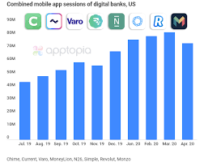

1. **Fintech:** Financial technology firms provide new solutions such as peer-to-peer lending, robo-advisors, and blockchain-based services.  
   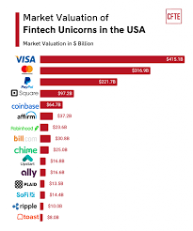
2. **Cybersecurity:** As banking becomes more digitised, there is a greater need for strong cybersecurity measures to prevent fraud and data breaches.

**Current Challenges:**

The US banking system faces several contemporary challenges:

1. **Regulatory Compliance:** Navigating the complex regulatory environment while being compliant with changing laws and regulations.
2. **Economic Conditions:** Managing the effects of economic volatility, interest rate changes, and global economic events.
3. **Technological Disruptions:** Keeping up with rapid technological advances and the emergence of fintech competitors.
4. **Cybersecurity Threats:** Protecting against more complex cyber threats while maintaining data security.

**Future Trends:**

Several trends are likely to shape the future of the US banking system:

1. **Artificial Intelligence (AI) and Machine Learning:** Improving customer service using AI-powered chatbots and personalising banking experiences with machine learning algorithms.
2. **Open Banking:** Allowing third-party developers to access bank customer data (with consent) in order to create new applications and services promotes transparency and competitiveness.
3. **Sustainable Banking:** Integrating environmental, social, and governance (ESG) considerations into banking processes and investment decisions.
4. **Decentralized Finance:** Using blockchain technology to provide financial services without traditional intermediaries.

**Conclusion:**

The United States banking system is a dynamic and sophisticated network of financial organisations, regulatory authorities, and technology advancements. It contributes significantly to the country's economic prosperity and stability. Understanding its structure, operations, and difficulties is critical for stakeholders in the financial industry.  
Comparing the US banking system to those of the UK, Japan, China, and India reveals both shared practices and unique issues faced by each country. This comparison emphasises the significance of specialised regulatory measures that reflect the unique demands and dynamics of each banking sector. Such comparisons can provide insights into policy decisions and build a more resilient and efficient global financial system.